**Experiment No. 1**

**Name: Sonali Dattatray Kaingade**

**PRN: 21620002**

**Title:** Study and use of different types of graphs and charts(use MS-XLS).

**1. Bar graph**

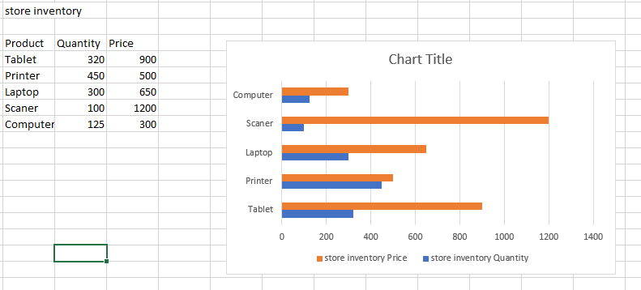

**2. Column graph**

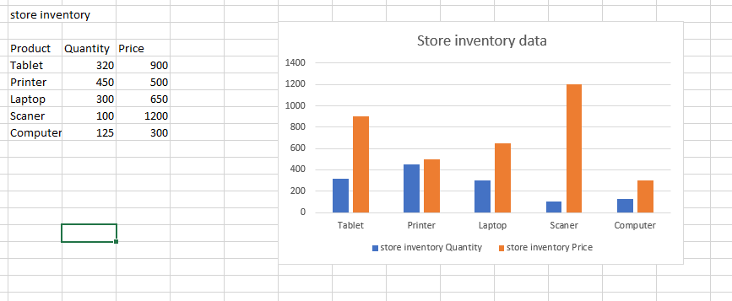

**3. Line chart**

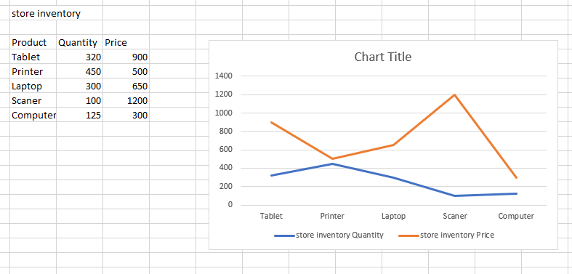

**4. Pie chart**

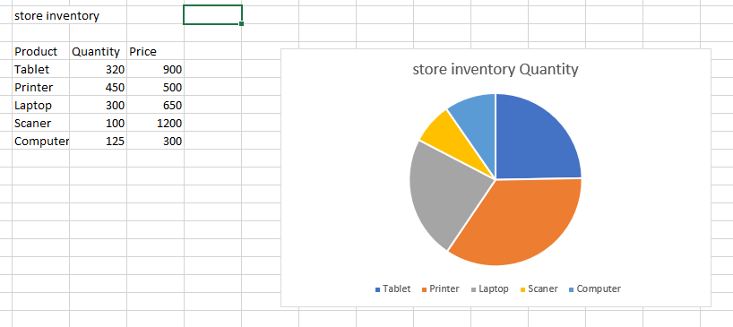

**5. Scatter chart**

